Volume= Length x Width x Height
Volume = 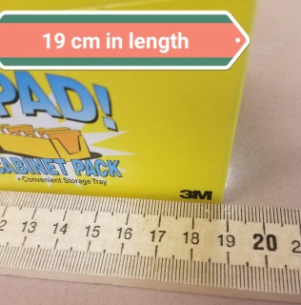 x 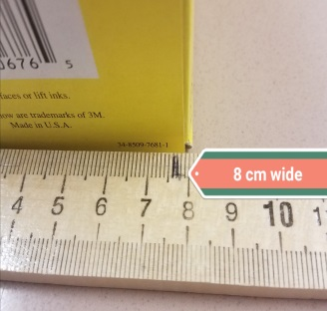 x 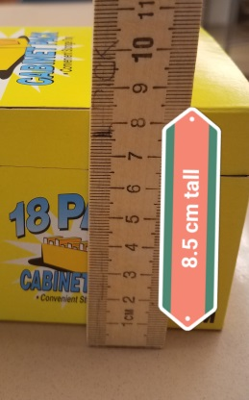

Volume = 19 c.m. x 8 c.m. x 8.5 c.m.

Volume = 1, 292 c.m.³

