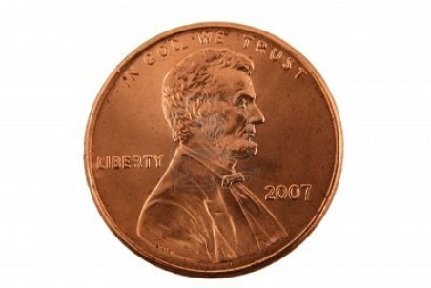

Equation to find the area of a circle $A=πr^{2}$
Radius = 0.375 inches
$$A=π{.375}^{2}$$
A = 0.441786 in²
Diameter = 0.75 inches
How many pennies fit in a square foot? How many pennies lined up will equal one foot?
Need to find this!

Diameter of one penny * ________ = 12 inches
0.75 inches * 10 pennies = 7.5 inches
0.75 inches * 12 pennies = 9 inches
0.75 inches * 14 pennies = 10.5 inches
0.75 inches * 16 pennies = 12 inches

Therefore, the pennies will be lined up with 16 rows and 16 columns to fit perfectly into one foot².

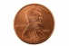

16 x 16 = 256 pennies in a square foot
Total Area: 105 feet²
105 (area) x 256 (pennies per ft²) = 26,880 pennies
Cost of the pennies : $268.80

